**Comprehensive Analysis of Gender Pay Gap and Telemetry Data Insights.**

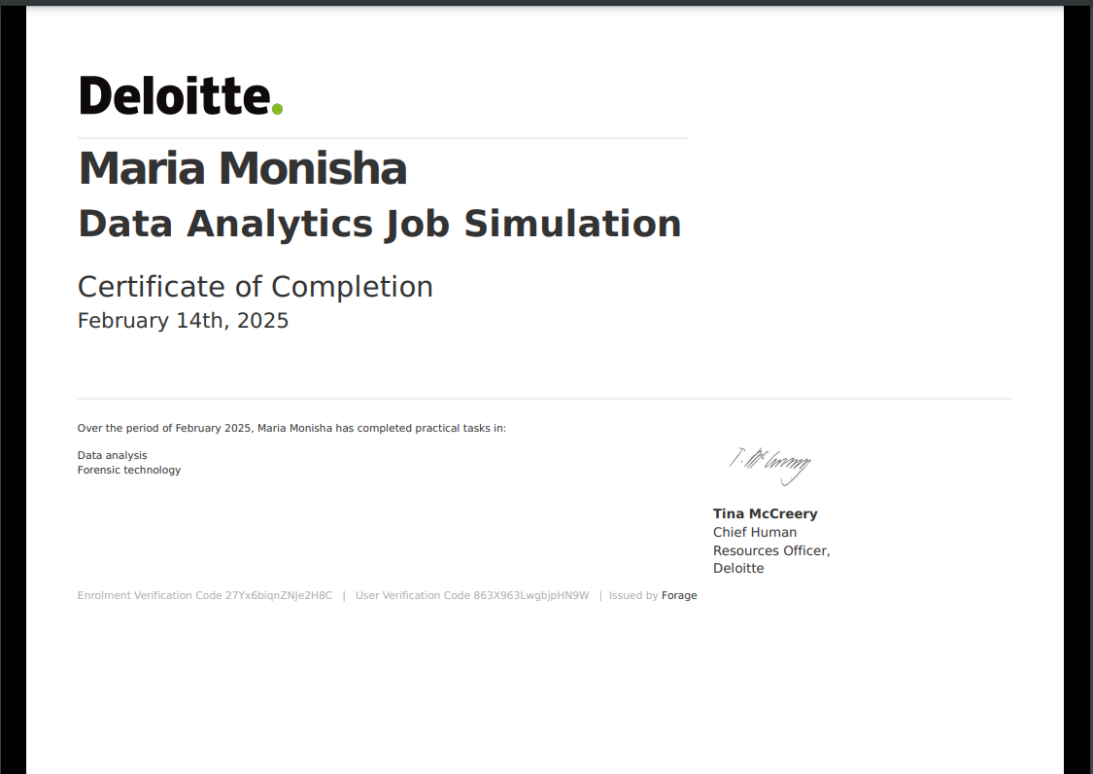**Certificate of completion**

**Table of contents:**

|  |  |
| --- | --- |
| **s.no** | **contents** |
| **1.** | **Introduction** |
| 1.1 | Task-1 |
| 1.2 | Background Information |
| 1.3 | Daikibo’s Manufacturing Facilities |
| 1.4 | Tools and Technologies Used |
| 1.5 | Methodology |
| 1.6 | Insights and Outcomes |
| **2** | **Task 2** |
| 2.1 | Background Information |
| 2.2 | Methodology |
| 2.3 | Insights and Observations |
| 3. | conclusion |

**1 . Introduction :**

I am **Maria Monisha J., a budding Data Analyst** passionate about uncovering insights through data. Recently, I had the privilege of completing **Deloitte Australia's Job Simulation program,** which offered a unique opportunity to experience the dynamic role of a **Data Analyst at Deloitte.**

This simulation provided a practical understanding of how data analysts contribute to solving complex business challenges. By replicating **real-world scenarios,** the program allowed me to hone my skills in **data visualization and analysis using Tableau**, alongside applying **logical reasoning to address critical problems.**

This document outlines my experience with the simulation, detailing the tasks I undertook, the tools and techniques I employed, and the insights I gained. It is an exploration of how this program has deepened my understanding of the Data Analyst role and prepared me to excel in a professional environment.

**1.1. Task-1 :**

As part of Deloitte Australia's Job Simulation program, I undertook a comprehensive analysis of telemetry data for **Macora Industries,** one of Deloitte’s prominent clients. Macora Industries faced significant challenges in their manufacturing process and sought data-driven insights to address these issues.

The data, collected using **Industrial Internet of Things (IIoT) technology**, was shared with Deloitte in a unified format by **Daikibo, their technical partner.** My role in this simulation was to analyze the data using Tableau to provide actionable insights that answer two key questions:

1. **Which factory location experienced the highest machine downtime?**
2. **Which machines contributed the most to this downtime at that location?**

This document details the methodology, tools, and outcomes of my analysis, showcasing how I leveraged Tableau and logical reasoning to identify critical patterns in the data.

**1.2. Background Information :**

Macora Industries had implemented IIoT technology across its manufacturing facilities to monitor and collect telemetry data. This data was shared by Daikibo, the technical team responsible for aggregating and unifying the information.

**1.3. Daikibo’s Manufacturing Facilities :**

The telemetry data was sourced from four factories, located in:

1. **Meiyo Factory** – Tokyo, Japan
2. **Seiko Factory** – Osaka, Japan
3. **Berlin Factory** – Berlin, Germany
4. **Shenzhen Factory** – Shenzhen, China

Each factory operates nine distinct types of machines. These machines sent status messages every 10 minutes, detailing their operational health. For the month of **May 2021**, telemetry data was collected and consolidated into a single JSON file.

The client aimed to analyse this data to pinpoint the factory with the highest machine breakdowns and identify the machines causing the most downtime at that location.

**1.4. Tools and Technologies Used :**

**1. Tableau**

* Installed the **free trial version of Tableau** to perform data analysis and visualization.
* Registered an account to access Tableau’s robust suite of tools.
* Imported the provided **daikibo_elementary_data.json** file into Tableau after unzipping it.

**1.5. Methodology :**

**Step 1: Creating a Calculated Measure Field**

To quantify machine downtime, I created a calculated measure field named **‘Unhealthy’** in Tableau. This measure:

* Assigned a value of **10** for every recorded ‘Unhealthy’ status message.
* Represented 10 minutes of potential downtime, as the machines send status messages at 10-minute intervals.

IF [Status] = 'Unhealthy' THEN 10 ELSE 0 END

This calculated measure served as the foundation for determining the total downtime for various factories and machines.

**Step 2: Visualization and Analysis**

Using Tableau’s intuitive interface, I created two key visualizations to address the client’s questions.

**1. Downtime Per Factory**

* Dragged the **Factory** field to the **Columns** section to represent each factory.
* Dragged the **Unhealthy** field to the **Rows** section to calculate total downtime.
* The resulting **bar chart** provided a clear view of the total downtime recorded at each factory location, allowing for a quick comparison.

**2. Downtime Per Machine**

* Dragged the **Device Type** field to the **Columns** section to represent each machine type.
* Dragged the **Unhealthy** field to the **Rows** section to calculate downtime for each machine type.
* The resulting **bar chart** highlighted which machines contributed the most to downtime across all factories.

**Step 3: Creating an Interactive Dashboard**

To provide a consolidated view of the analysis, I created a **dashboard** in Tableau:

* Combined the **Downtime Per Factory** and **Downtime Per Machine** charts into a single dashboard.
* Enabled interactivity by syncing the charts using the **Filter (Funnel)** icon.

This feature allowed users to:

* Select a specific factory in the **Downtime Per Factory** chart.
* Automatically display the corresponding machine downtime in the **Downtime Per Machine** chart.

**1.6. Insights and Outcomes :**

**Findings**

1. **Factory with Highest Downtime**: The analysis identified the factory with the highest recorded machine downtime during May 2021.
2. **Machines Causing the Most Downtime**: The dashboard revealed the specific machines contributing significantly to downtime at the selected factory location.

**Impact**

This analysis demonstrated the power of data visualization and interactive dashboards in extracting actionable insights from raw telemetry data. The findings provided Macora Industries with a clear roadmap for addressing inefficiencies and improving their manufacturing process.

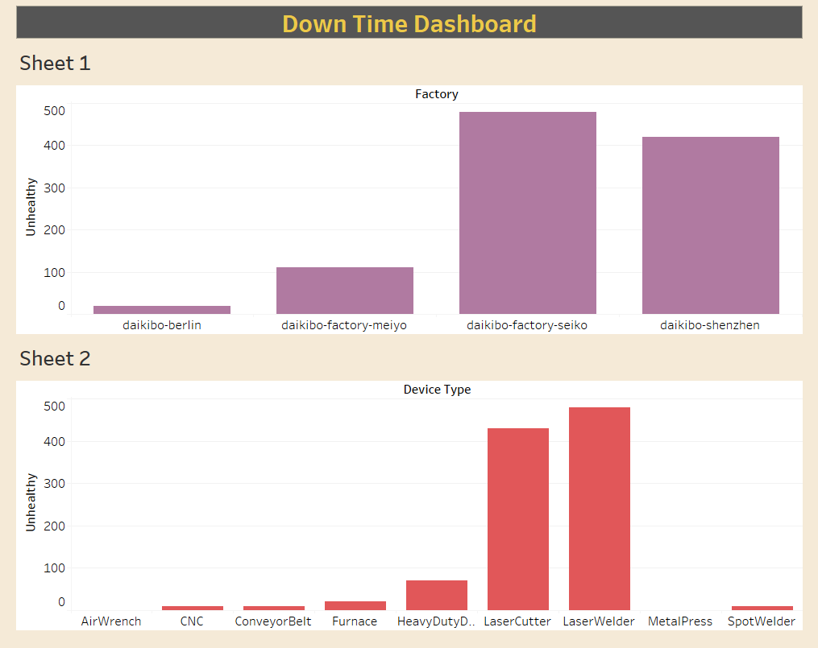

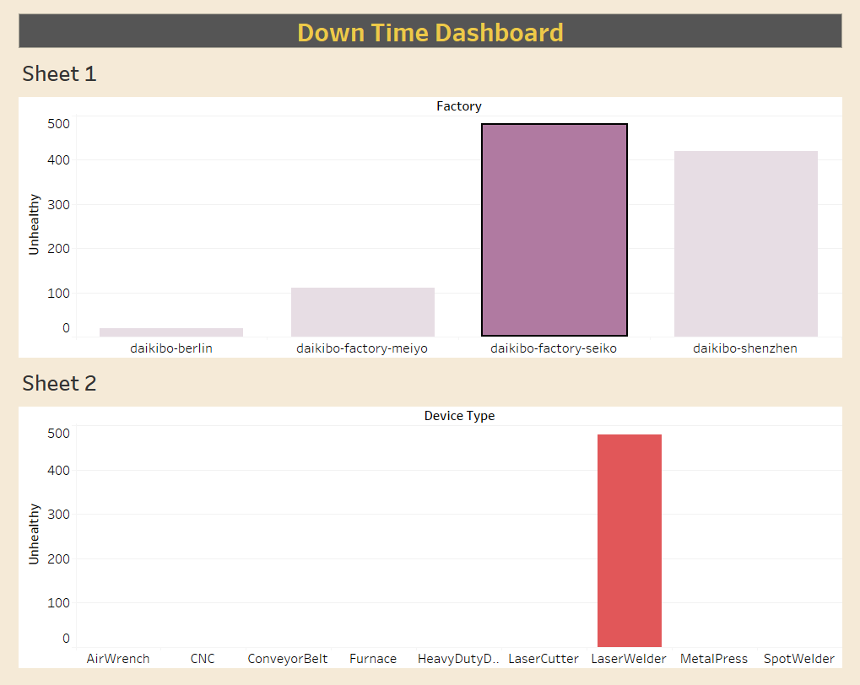

**2.Task 2 :**

Macora Industries, a valued client of Deloitte, approached us with a critical and sensitive issue: **addressing gender pay inequality across their organization.** This initiative aimed to identify disparities in compensation based on gender and classify job roles into categories to guide corrective actions.

The task involved analyzing data processed by Macora's forensic technology team and creating a classification framework for understanding pay equality. This project provided me with an opportunity not only to demonstrate my analytical skills but also to contribute to a meaningful cause that promotes workplace equity.

**2.1. Background Information :**

Macora Industries has faced internal complaints about gender inequality in compensation across various roles and locations. To address these concerns, their forensic technology team developed an algorithm that calculates a **"Gender Pay Equality Score"** for each job role across all factories.

The **Gender Pay Equality Score** is represented as an integer ranging from **-100 to +100**, where:

* **0** indicates ideal equality.
* **Negative scores** indicate a bias against women.
* **Positive scores** indicate a bias against men.

The processed data was shared in an Excel file containing three columns:

1. **Factory** – The location of the factory.
2. **Job Role** – The role designation in the factory.
3. **Equality Score** – The calculated score for pay equality.

I was tasked with analysing this data, classifying job roles into categories based on the equality score, and providing actionable insights to Macora Industries.

**2.2. Methodology :**

**Step 1: Understanding and Preparing the Data**

* **File Format**: The data was provided as an Excel file.
* **Columns Provided**: Factory, Job Role, and Equality Score.
* I reviewed the data to understand its structure and ensure its integrity before proceeding with the analysis.

**Step 2: Creating the Classification Framework**

To provide a clear picture of the pay inequality levels, I created a new column named **Equality Class** and used the following classification logic:

* **Fair**: Scores between **-10 and +10** (inclusive).
* **Unfair**: Scores less than **-10** or greater than **+10** but within **±20**.
* **Highly Discriminative**: Scores less than **-20** or greater than **+20**.

**Step 3: Implementing the Classification**

Using Excel's formula capabilities, I created the **Equality Class** column to categorize each job role's equality score:

* **Formula Logic**:
  + If the score was between **-10 and +10**, it was classified as **Fair**.
  + If the score was less than **-10** or greater than **+10**, but within **±20**, it was classified as **Unfair**.
  + If the score was less than **-20** or greater than **+20**, it was classified as **Highly Discriminative**.

**Step 4: Analysing Results**

I analysed the classified data to identify trends, such as:

* Factories with the highest instances of unfair or highly discriminative roles.
* Job roles that consistently exhibited pay disparities.

This analysis highlighted the problem areas, enabling Macora Industries to focus on addressing the most critical disparities.

**2.3. Insights and Observations :**

1. **Fair Roles**:
   * The majority of job roles in certain factories fell within the **Fair** category, indicating satisfactory levels of gender pay equality.
2. **Unfair Roles**:
   * Several roles exhibited minor deviations from ideal equality, suggesting a need for review and adjustment.
3. **Highly Discriminative Roles**:
   * A small but significant portion of roles showed severe pay inequality. These roles and their corresponding locations should be prioritized for corrective actions.

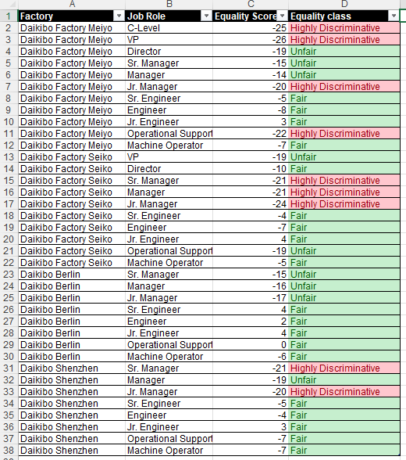

**3 . Conclusion :**

This project provided Macora Industries with a comprehensive view of gender pay inequality across their factories. By categorizing job roles into **Fair**, **Unfair**, and **Highly Discriminative**, the analysis offered a clear roadmap for addressing pay disparities.

In addition to addressing the gender pay gap, I also successfully completed **Task 1**, where I analysed telemetry data collected from Macora's factories to identify the locations and machines with the highest downtimes. Using Tableau, I visualized the downtime trends across four factories—Meiyo (Tokyo, Japan), Seiko (Osaka, Japan), Berlin (Germany), and Shenzhen (China).

This combined effort has not only helped Macora Industries gain valuable insights into their operational challenges but also contributed to their journey toward equity and efficiency. These tasks showcased my analytical, visualization, and problem-solving skills, emphasizing the role of data in driving meaningful organizational improvements.

## **Thank you.**

Contact me through ,

Email : [hiremaria17@gmail.com](mailto:hiremaria17@gmail.com)

LinkedIn : [https://www.linkedin.com/in/maria1709](https://www.linkedin.com/in/maria1709?lipi=urn%3Ali%3Apage%3Ad_flagship3_profile_view_base_contact_details%3BR6nxL65rSouFkhom1AmqbQ%3D%3D)